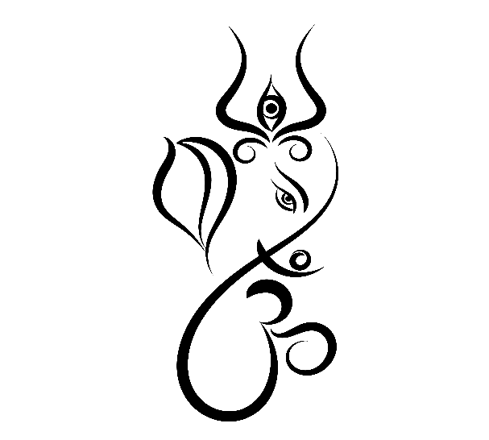

**Warm Invitation**

*A Cordial Invitation*

*Mrs. Vinita & Mr. Pradeep Rajput*

*Rajvilla, Mannupuram St-2, Kiratpur Road,*

*Bijnor - 246701*

*Mob. : +91-9927026846, +91-9756834563*